**Lesson 4 - Further numbers and demonstratives**

**Numbers 11-100**

11 - juu ichi *[juu (10) + ichi (1)]*

12 – juu ni

13 – juu san

20 – ni juu *[ni(2) x juu (10)]*

21 – ni juu ichi *[(ni juu (20)+ichi (1)]*

22 – ni juu ni

25 – ni juu go

27- ni juu nana

30- san juu

36 – san juu roku

38 – san juu hachi

40 – yon juu

70 – nana juu

79 – nana juu kyuu

85- hachi juu go

88- hachu juu hachi

90 – kyuu juu

93 – kyuu juu san

100 – hyaku

**Vocabulary:**

Hon – book

Kaban – bag

Pasokon – Computer

Pen – pen

Keshigomu – eraser

Nooto – notebook

Keitai – phone

Botoru - bottle

**Demonstratives:**

Kore - this

Sore - that

Are – that over there (far from speaker and listener)

Dare no – Whose?

Nani/Nan - What?

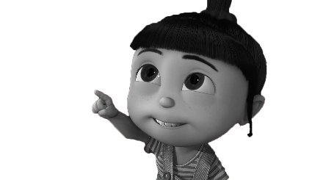

Kore wa pen desu.

Sore wa pen desu.

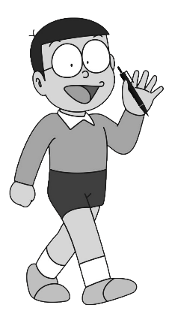

are wa pen desu.



**Grammar and demonstratives:**

Q: sorewa nan desu ka? – What is that?

A: korewa pen desu. – This is a pen.

Q: sorewa dareno pen desu ka? – Whose pen is that?

A: Korewa watashino pen desu. – This is my pen.

OR

A: korewa Suzuki san no pen desu ka? – Is this Suzuki san’s pen?

B: hai, soudesu. – Yes, it is.

Iie, Suzuki san no JANAI* desu. Watashino desu. – No it is not Suzuki san’s. It is mine.

*Janai makes a statement negative.

**Hiragana!!**

**た** – TA だ – DA

**ち** – CHI ぢ – JI

**つ** – TSU づ - ZU

**て** – TE で - DE

**と** – TO ど - DO

|  |  |  |  |  |  |  |  |
| --- | --- | --- | --- | --- | --- | --- | --- |
| た |  |  |  | だ |  |  |  |
|  |  |  |  |  |  |  |  |
|  |  |  |  |  |  |  |  |
|  |  |  |  |  |  |  |  |
|  |  |  |  |  |  |  |  |

|  |  |  |  |  |  |  |  |
| --- | --- | --- | --- | --- | --- | --- | --- |
| ち |  |  |  | ぢ |  |  |  |
|  |  |  |  |  |  |  |  |
|  |  |  |  |  |  |  |  |
|  |  |  |  |  |  |  |  |
|  |  |  |  |  |  |  |  |

|  |  |  |  |  |  |  |  |
| --- | --- | --- | --- | --- | --- | --- | --- |
| つ |  |  |  | づ |  |  |  |
|  |  |  |  |  |  |  |  |
|  |  |  |  |  |  |  |  |
|  |  |  |  |  |  |  |  |
|  |  |  |  |  |  |  |  |

|  |  |  |  |  |  |  |  |
| --- | --- | --- | --- | --- | --- | --- | --- |
| て |  |  |  | で |  |  |  |
|  |  |  |  |  |  |  |  |
|  |  |  |  |  |  |  |  |
|  |  |  |  |  |  |  |  |
|  |  |  |  |  |  |  |  |

|  |  |  |  |  |  |  |  |
| --- | --- | --- | --- | --- | --- | --- | --- |
| と |  |  |  | ど |  |  |  |
|  |  |  |  |  |  |  |  |
|  |  |  |  |  |  |  |  |
|  |  |  |  |  |  |  |  |
|  |  |  |  |  |  |  |  |

**WORDS FOR PRACTISE:**

Tokei - ____________ (watch)

Shichi - ____________ (seven)

Kutsu - ____________ (shoes)

Chikatetsu - ____________ (subway)

いたい – ____________ (pain)

つくえ – ____________ (desk)

たかい - ____________ (expensive, tall)

つき - _______________ (month, moon)

**Vocabulary list:**

PLACES

Toire – toilet

Toshokan – library

Kissaten - cafe

Ginko – bank

Machi- city

THINGS

Terebi – TV

Kutsu – shoes

koohii – watch

gohan – mean, rice

juusuu - juice

**Homework:**

* Revise numbers from 1-10
* Practice hiragana
* Read today’s vocabulary list